REPORT ON LIBRARY ORIENTATION PROGRAMME
Organised by: Central Library, Sapatgram College
Date: 10 September 2026
Venue: Central Library, Sapatgram College
The Central Library of Sapatgram College organised a Library Orientation Programme on 10 September 2026 for the students of the college. The programme was organised with the objective of familiarising students with the library and its various resources, facilities, rules and services.
The programme was graced by the presence of Librarian-in-Charge, Mr. Argeng Narzary, IQAC In-Charge, Dr. Chaitali Bhowmick, and Library Assistant, Mr. Kaushik Guha. Their presence and guidance contributed significantly to the successful organisation of the programme.
During the orientation programme, the students were introduced to the different sections and facilities of the Central Library, including the textbook section, reference section, periodical section and other available learning resources. The students were also informed about the proper procedures for library membership, issue and return of books, renewal of books, use of library cards/smart cards, and searching for books.
The students were made aware of the importance of maintaining discipline and silence inside the library and taking proper care of library books and other resources. They were also encouraged to develop a regular reading habit and make effective use of the library for their academic and intellectual development.
The programme also highlighted the importance of digital and online library resources. Students were encouraged to make use of authentic academic resources available through the library for their studies, assignments and overall academic development.
The students actively participated in the programme and interacted with the library personnel regarding various library services and facilities. Their queries were addressed appropriately, making the session informative and useful.
The Library Orientation Programme concluded successfully with an emphasis on the effective and responsible use of library resources. The programme was beneficial in creating awareness among students about the facilities and services of the Central Library and encouraging them to become regular users of the library.

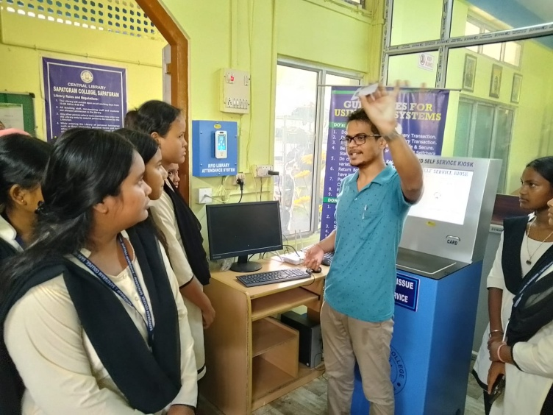
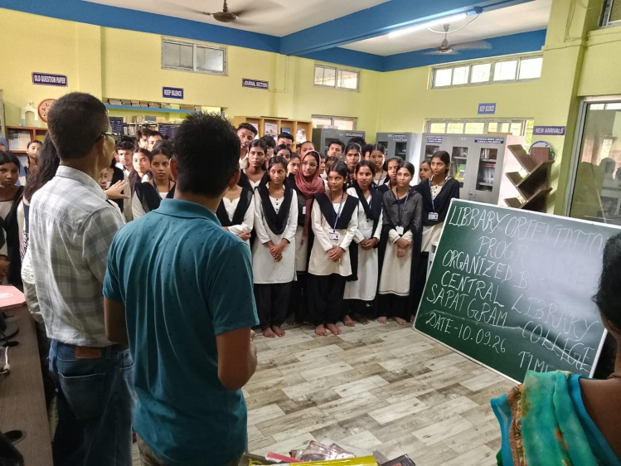
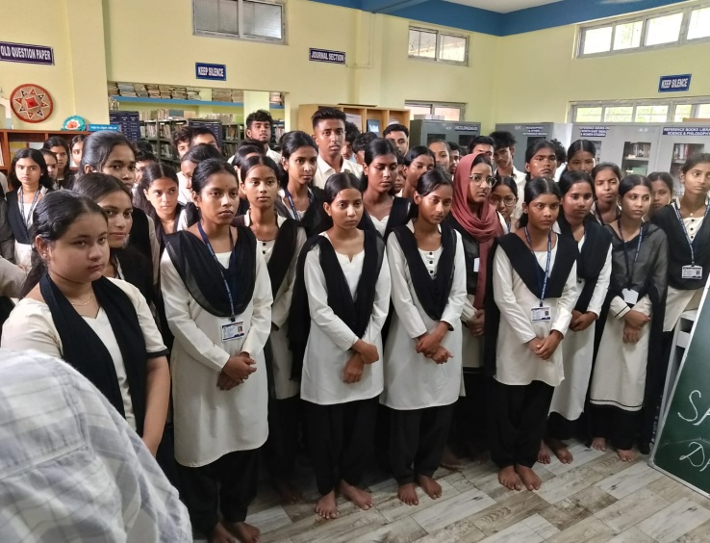
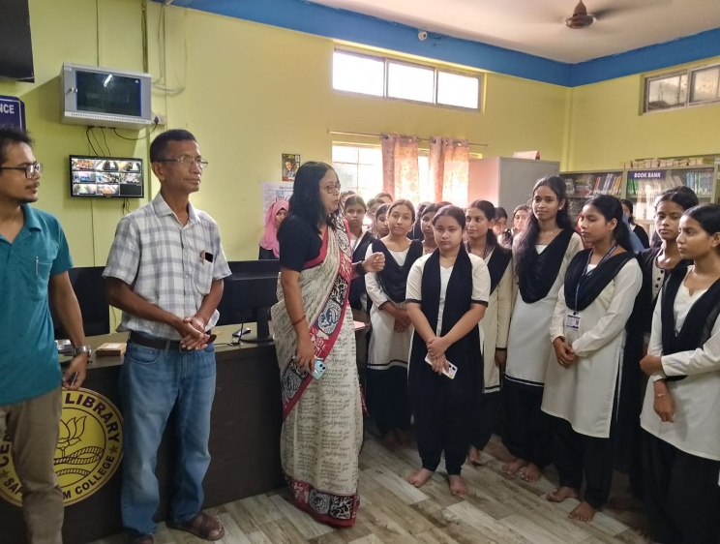
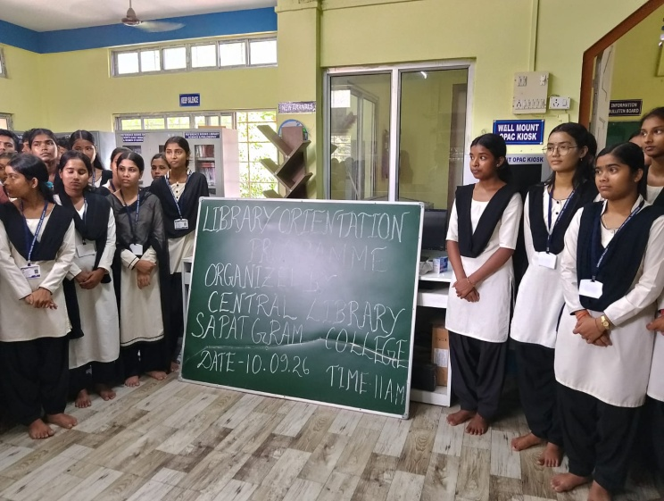
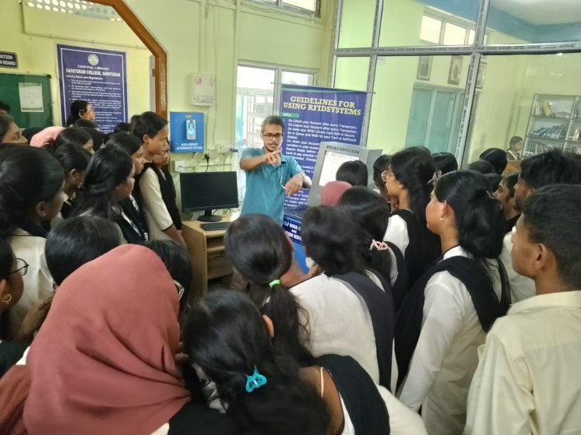
Principal Librarian I/c
Sapatgram College Central Library, Sapatgram College

